**User interface evaluation for AUMS**

Name: Manomithran

Roll.no: CB.EN.U4CYS21040

The AUMS website is a portal for the students, faculty and staff at Amrita University to access information and resources related to their academics, library and other personal college status. The website can also host exams and make important announcements using the calendar. The website can be used by anyone in the college regardless of the department.

The content is organized in a clear and logical way and is relatively easy to use with clear and concise navigation and clearly labelled links. Some of the text on the page is small and the interface changes for different browsers. This can be changed and be made uniform for different users in different browsers so that it improves the user experience.

The website does a good job of resolving errors by providing clear instructions and input validation. It also handles the error pretty well by displaying clear and helpful error messages. Some pages take time in loading and processing the content on the screen and it can be frustrating for the users. It has a clear professional design with a minimalistic approach on the layout which helps the users focus more on the content. However, it is difficult to read in certain pages de to the small text size and low contrast between text and background.

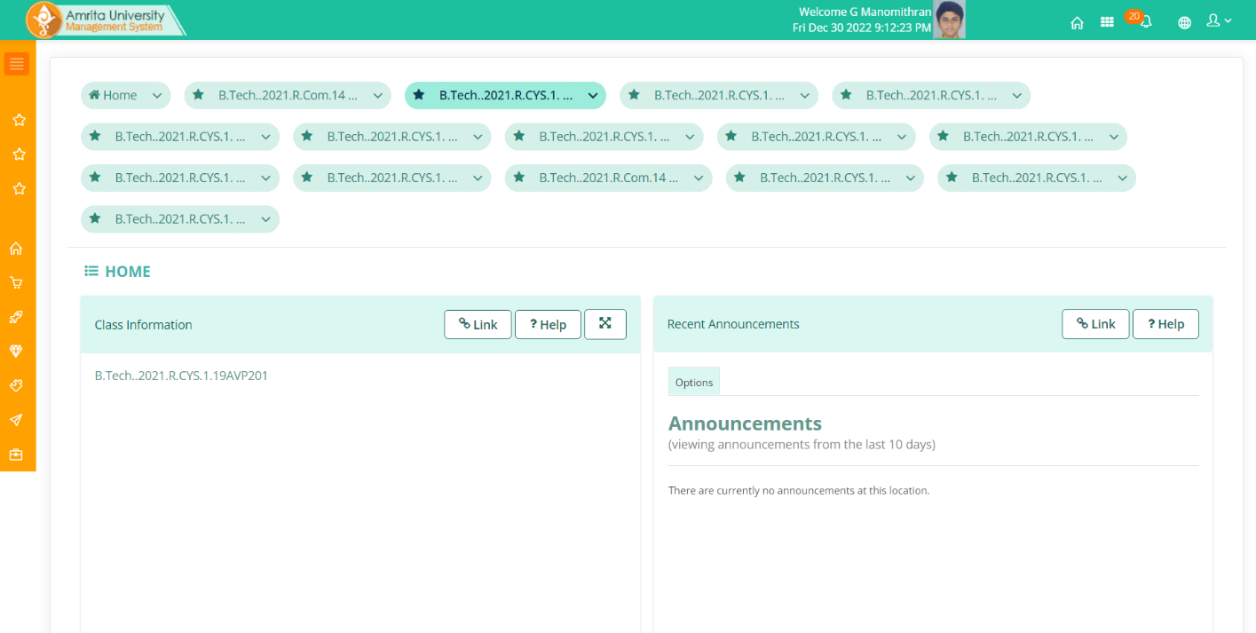

*Home page*

There is also a certain login error which has the user login twice. We have to open the website in another new tab to overcome this error. This error is particularly infuriating for the users as the content is not displayed properly after logging in twice.



The header icons of the webpage are home, courses, notifications, location selector and personal information.

The homepage shows all the registered courses from where you can navigate separately to different tabs such as the resources, assignments, tests, etc.

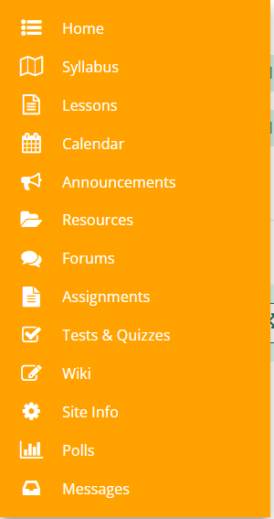

When you click on the registered courses, the page automatically shows the information on the course, announcements made specifically for the course and calendar that shows the events for the day regarding the course.

To the left side, there is a tab that contains the favourite pages and the Main menu that has the

1. Registration:

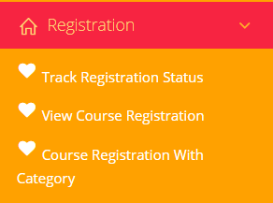

This shows the courses that the user has registered and also enables them to register for upcoming courses.

1. Exam Scores:

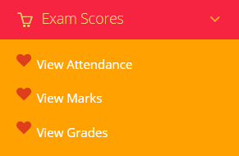

This shows the attendance summary for the previous and current semester. The same goes for the marks and grades tab.

1. Fees

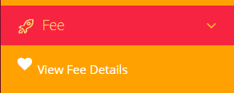

The fees details are not visible and are not updated in aums.

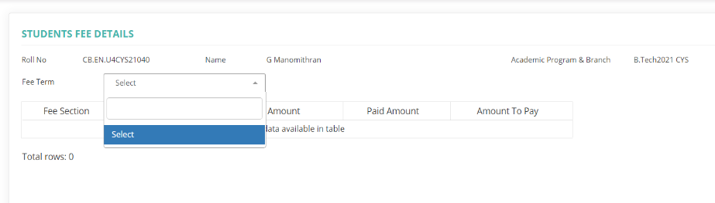

1. Dues

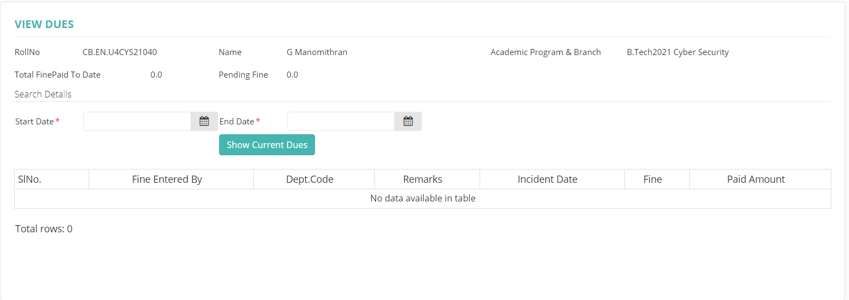

Displays the pending fine and all the other details regarding it.

1. Personal

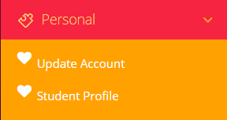

Shows all the information that the student or faculty have given to the institution.